Assignment  
Model Management

short line

# Task Summary

Develop a model management web application to manage model information like below picture

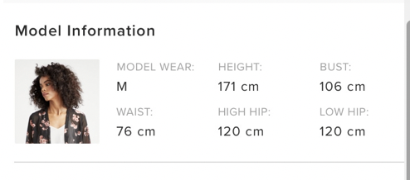

# Features to implement

1. Listing / Searching of models by name and different attributes
2. Adding / Edit Model Information
3. Uploading multiple images using drag and drop

# Use below technologies:

1. Nodejs
2. MongoDB
3. ReactJs
4. Free to use opensource libraries for upload, drag and drop etc.

# Time allotted: 3 days.

# Plus Points:

1. Readable code and following good coding standard
2. Functional programming
3. Neat UX.